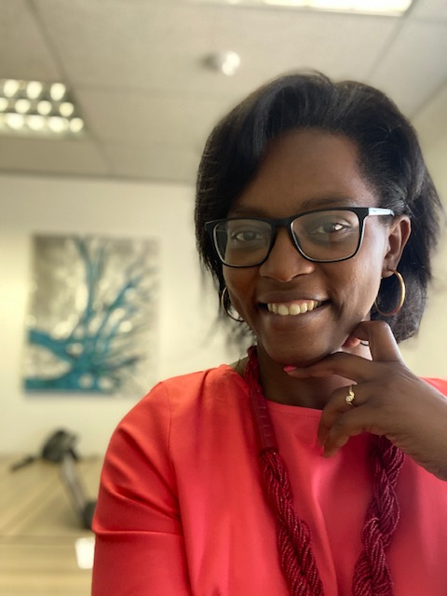

Hello, my name is Eva Arissani, I am the Founder and Director of Transcentral Pty Ltd, a company specializing in language services and coaching programmes (translation, interpreting, voice over, corporate trainings, coaching programmes etc.); I am the Co-Founder & Executive Director of She Phoenix Femme Phoenix(SPFP) , an NPO which aims at empowering and inspiring the Girl Child, teenage girls, young women, at advocating for their rights to a better life, at raising awareness about a daunting range of obstacles they are facing on a daily basis (such as child marriages, abuse, lack of self-esteem, peer pressure, teenage pregnancy, etc.), striving to reduce underage pregnancies and violence against girls, young women, children, advocating to keep girls in school, I am also the Published Author of New Moi New Life : Five Ways to Build a New You and Live an Extraordinary Life, a motivational book, aimed at creating a spiritual awakening that would encourage the reader to willingly make the necessary changes and move towards a fulfilling life. I am currently writing my second book which will be published this year. I recently became a member of Global Goodwill Ambassadors Foundation for my humanitarian work. I am also a Global Goodwill Ambassador; a recognition I am very grateful for as this expands my horizon and gives me the opportunity to reach my goal which is to empower 1000 000 girls worldwide by 2030.
I specialize in translation, interpreting, proofreading, editing, voice over, corporate training, facilitation, coaching and offer language services to individuals and businesses of all sizes around the world, ultimately giving them a global edge by transcending any language barriers they encounter.
I hold a Baccalaureus Artium Honores (English, French and Translation studies) from the University of Pretoria, South Africa and have over 13 years of experience in the language industry, having occupied positions of authority in the abovementioned fields.
I am a Mom, a Wife, a Sister, a Friend, a Child of God, an Active citizen, a Blogger, a Facilitator, a Women’s and girl’s Advocate, a Free spirit, a Leader, a Global Speaker, a Humanitarian and much more. I paid my dues to the University of life and I am determined to leave my mark…In a nutshell, I am a multidimensional global woman juggling business, family, spirituality, philanthropy and much more, striving to live a balanced life and to impact the world in a very positive manner.
My moto is: We all have a past. But how it influences our present and our future is up to us.
“It is a blessing for me to be a Girl Child empowerment Champion as I believe that it takes a group of extraordinary women from all walks of life, who conquered life, to empower our daughters and sisters from the global community”. ~ Eva Arissani
Contact Information :
E-Mail Address: director@transcentral.co.za
Facebook Page: https://www.facebook.com/EvaArissaniThetranslator/
https://www.facebook.com/newmoi.org/
https://www.facebook.com/SHE-Phoenix-FEMME-Phoenix-1579644932111579/?ref=bookmarks
https://www.facebook.com/newmoi.org/
LinkedIn : https://www.linkedin.com/in/eva-arissani-translation-expert-b539a658/
Instagram: https://www.instagram.com/evaarissani/
Twitter: @EvaArissani / @NpcShe

